AI ASS 21.5
Name:B.Sanjana
Batch:43
H.T.NO:2303A52306

#TaskA:
Prompt:
Generate a basic Python program for a Student Grade Calculator.
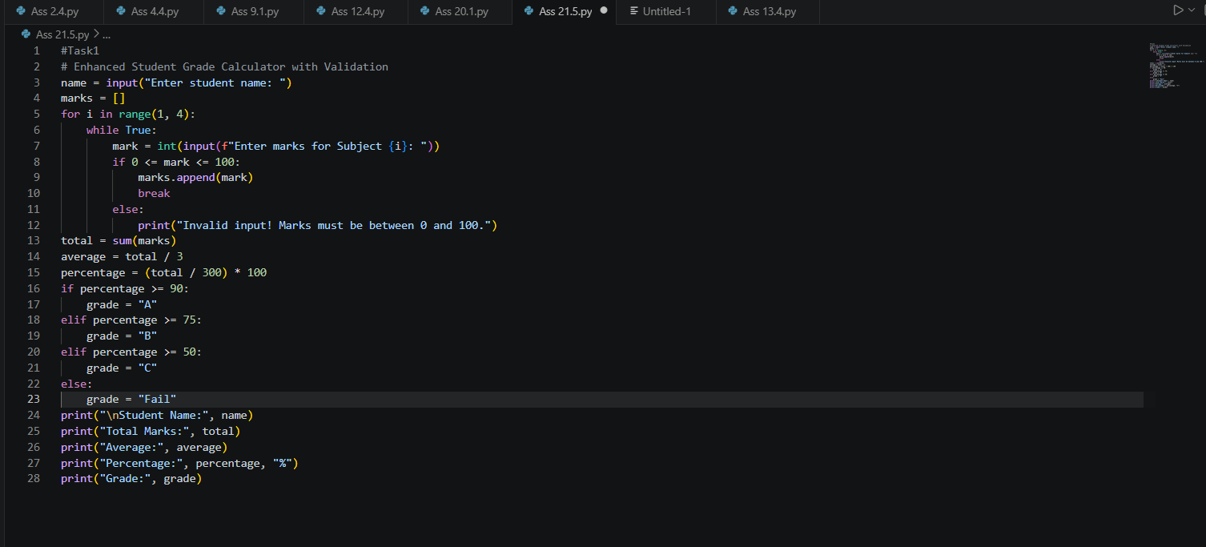
Output:
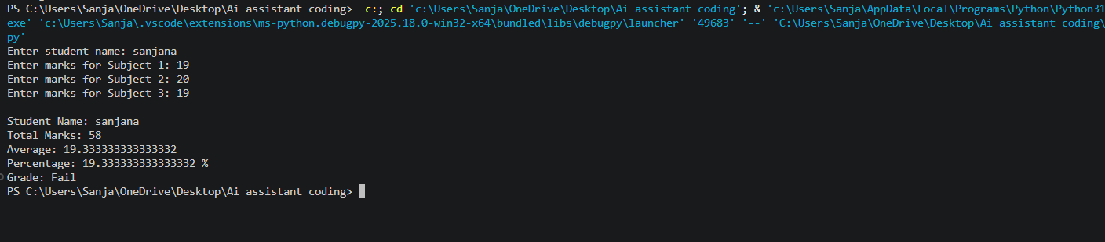
Observation:
- The basic version only calculates total and average marks.
- The enhanced version improves the program by:
  - validating marks input
  - preventing invalid values
  - calculating percentage
  - assigning grades
- The second version is more user-friendly, accurate, and reliable.
#TaskB:
Prompt:
Improve the Library Management program by adding book return, search, and display features.
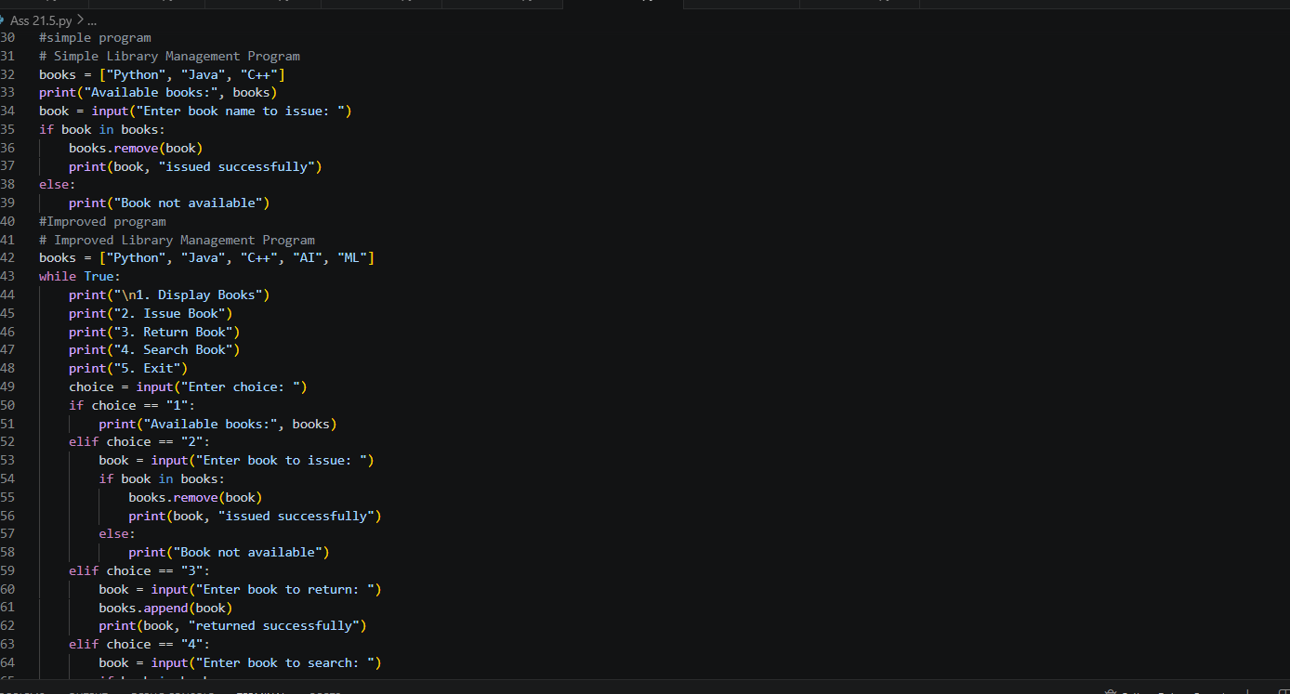
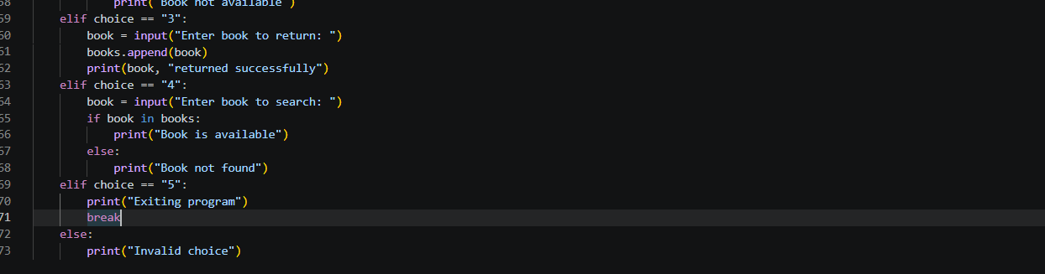

Output:
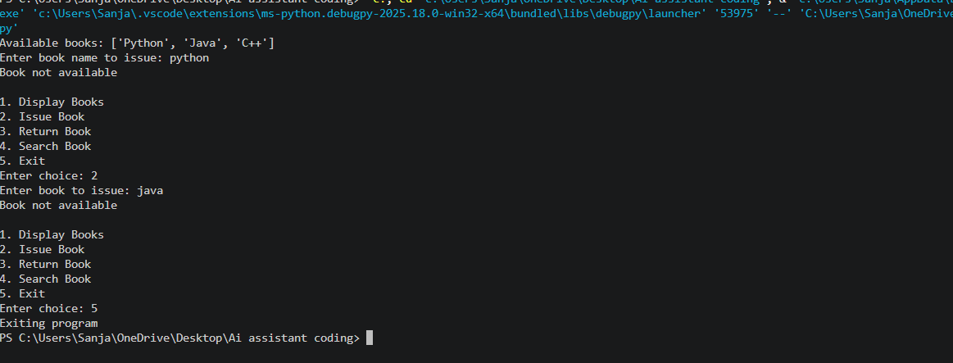

Observation:
The initial version performs only book issuing.
The improved version includes:
- display books
- issue book
- return book
- search book
- menu-driven structure
The enhanced version has better structure, improved functionality, and higher usability.

#Taskc:
Prompt:
Git workflow practice:
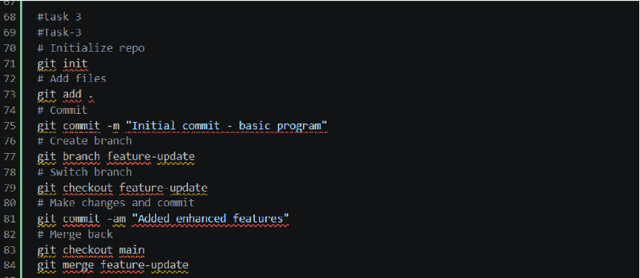
observation:
Git helps manage versions and track AI-generated changes effectively.
Branching allows safe experimentation before merging into the main project.

#TaskD:
Prompt:
Generate a Python program for Student Grade Calculator and improve it in a feature branch by adding grade classification and validation.
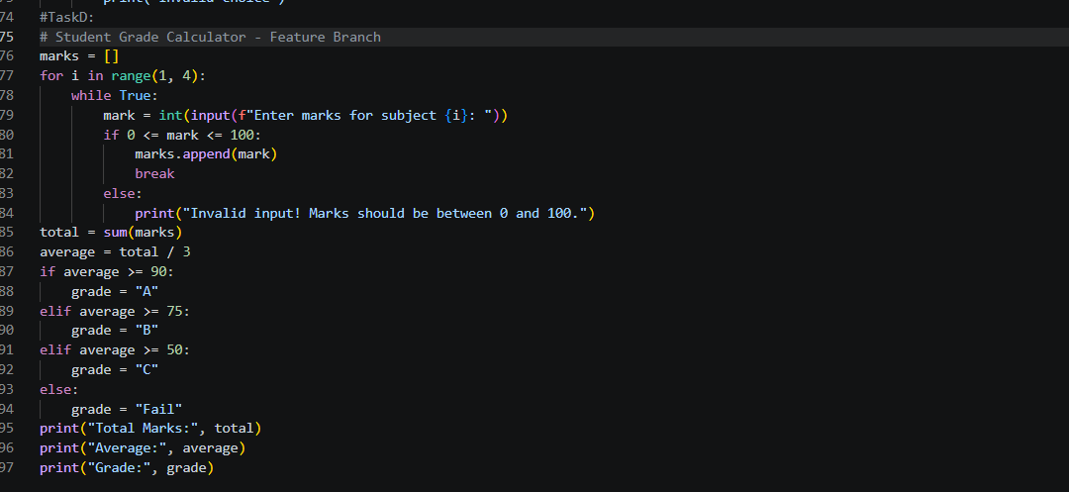

Output:
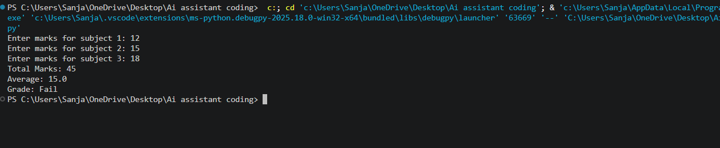

Observation:
The main branch contains the basic version of the program.
A feature branch was created for enhancements.
AI support was used to improve the program with:
- input validation
- grade calculation
- better structure
After merging, the main branch successfully contains the updated features.
Output verification confirms the merge was successful.

#TaskF
Prompt:
Generate a simple Python To-Do List program. Then enhance it using AI by adding delete task, view tasks, and exit options. Integrate changes using Git.
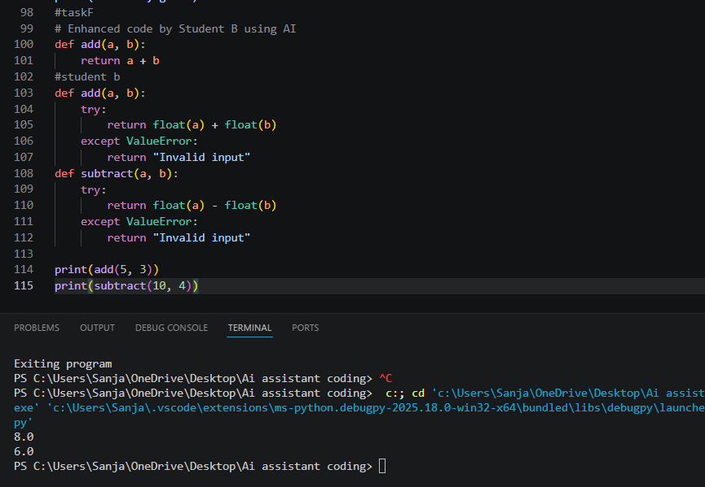
Observation:
Student A created a basic addition function.
Student B enhanced it by adding error handling and a subtraction function.
The updated code is more reliable, supports decimal values, and handles invalid inputs safely.

